Gravity form bug

1 billing and shipping address not show in customer and invoice table.
2 add some new field like
[INVOICE LINE ITEM]
Category, Description, Quantity, Price)

[ADDITIONAL FEES]
Fee Description, Amount

fax,due date,po number etc.

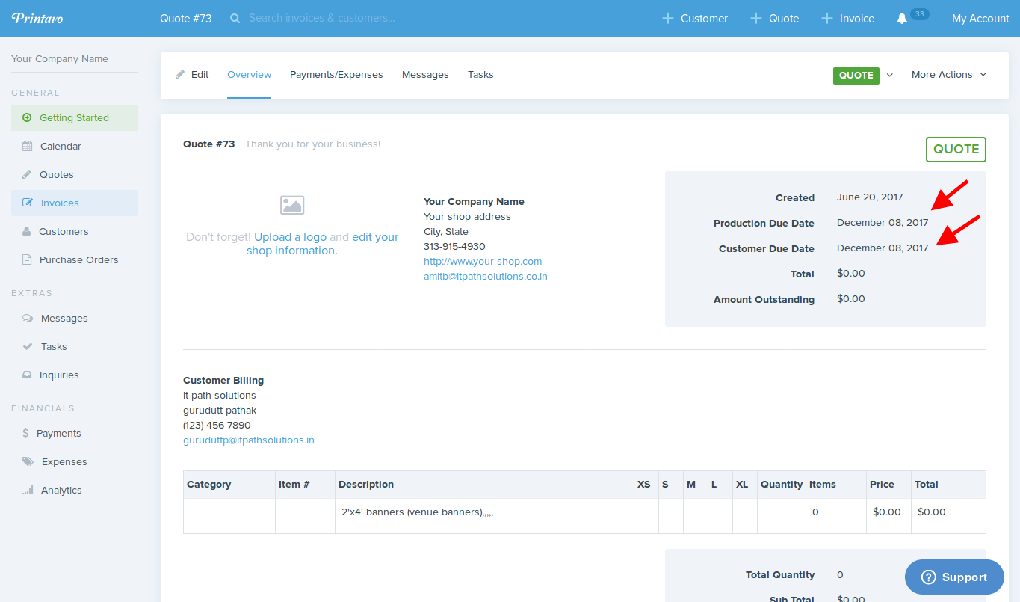
3 change production and customer due date.
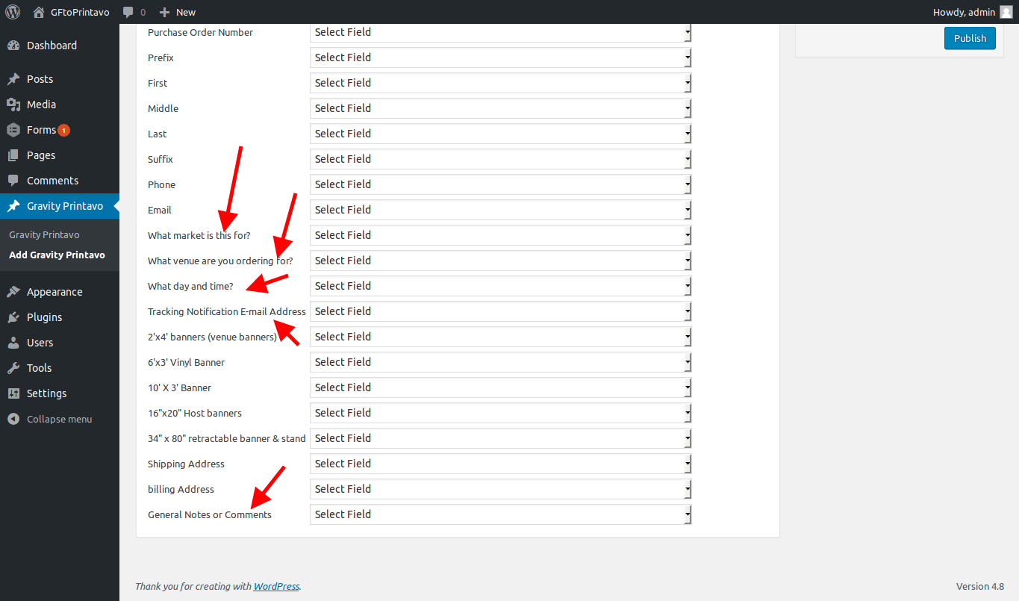
4 in gravity form most of label value not show in drop down than how we can mapping.

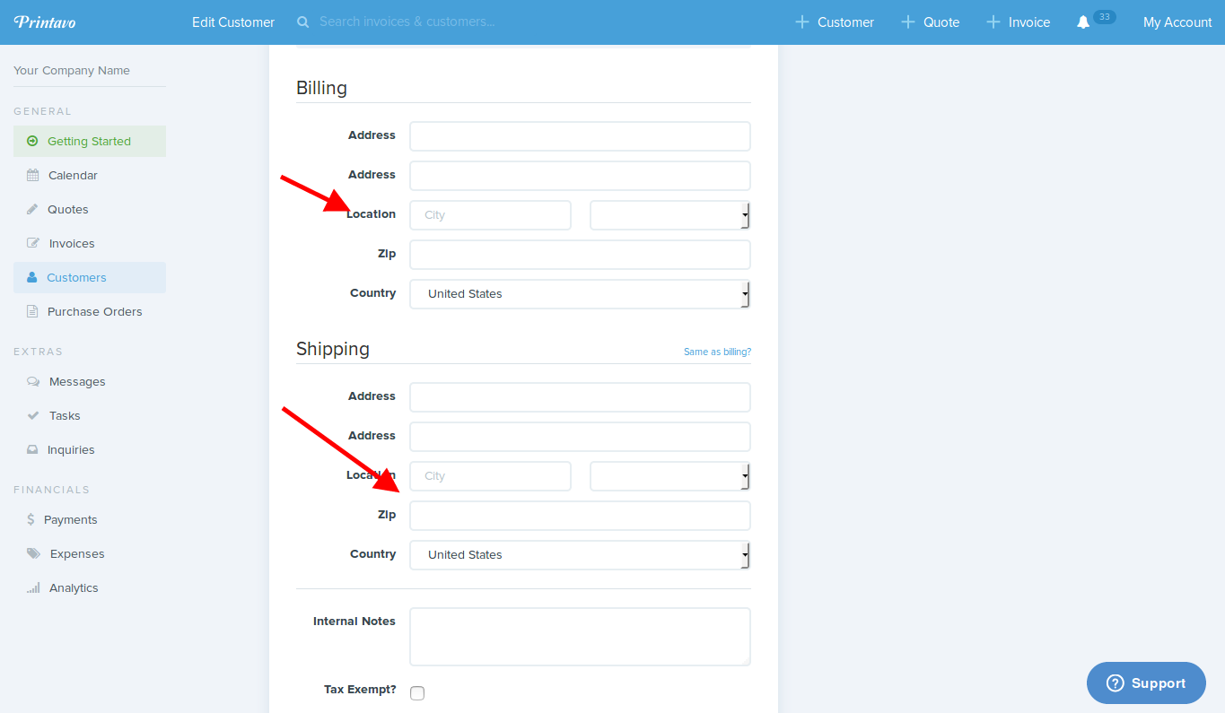
5 in edit page shipping and billing address not show.

